Client Brief:
Create a punchy, aggressive brand manifesto for the emerging streetwear label “Raptor Altare”.

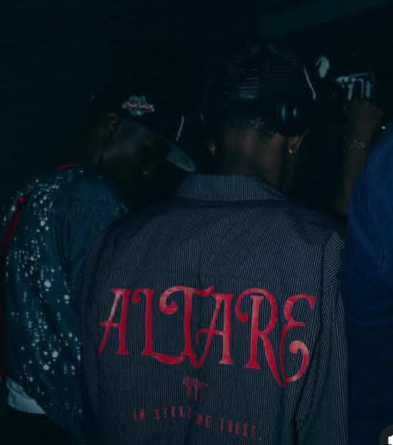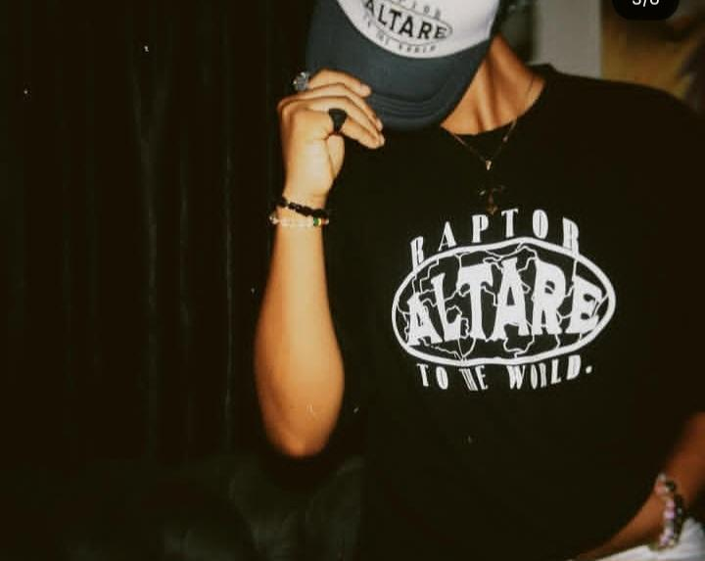

RAPTOR ALTARE; Built for the Concrete Jungle.
Silence the noise, Wear your roar.
​
Streetwear is often misunderstood; critics call it a trend, those who truly know it know it’s an expression. In a world that demands you fit into neat little boxes, true style is the act of breaking out, seeking originality as averse to expected conformity, valuing function over dictates.

​Our latest collection isn't designed for the runway, it’s designed for you, for the reality of the street, for your reality. From heavyweight cotton that survives the daily grind to silhouette pieces that take up space and give you space, and everything else in between; our designs don't ask for validation, they don’t obey the uniform rules, we create freedom, we create the new and untamed, we make art.

​Whether you're navigating the chaotic traffic of the city or building your legacy in silence, you need gear that keeps up and stands out, according to your rules. Don't just get dressed. Suit up.

Shop the Drop. Define Your Era.
​

